Schedule a Teams meeting from Outlook
Microsoft Teams
Microsoft Teams includes the Outlook add-in, which lets you create new Teams meetings directly from Outlook. You can also view, accept, or join meetings in either app.
Note: Currently, you can schedule Teams meetings from Outlook, but not choose a channel to have them in.
Desktop and web version

In this article
Schedule a Teams meeting
Remove Teams from a meeting
Make all meetings Teams meetings

Schedule a Teams meeting

Outlook on the desktop
- Open Outlook and switch to the calendar view.
- Select New Teams Meeting at the top of the view.
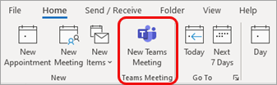
Note: Even if you begin by selecting New Meeting or New Appointment, you can make it a Teams meeting by selecting Teams Meeting at the top of the new event form.
- Add your invitees to the Required or Optional field(s)—you can even invite entire contact groups (formerly known as distribution lists).
- Add your meeting subject, location (if applicable), start time, and end time.
- Create your message.
- Select Send.
Note: The Teams meeting join details are added to the meeting invite automatically.
If you don’t see the New Teams Meeting icon in the desktop version of Outlook, the Teams add-in for Outlook might not be installed properly.
- For automated troubleshooting, you can run the Microsoft Support and Recovery Assistant.
- To manually troubleshoot this problem, see Use the Teams Meeting add-in in Outlook.

Outlook on the web
- In the new event form, select the Teams meeting toggle to turn it on.
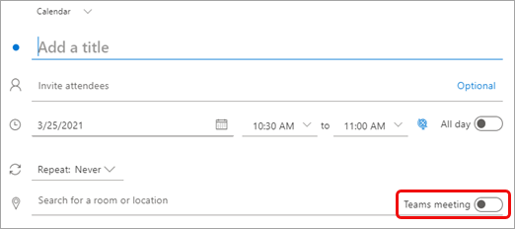
After the invite is sent, you'll see the meeting join details in the event.

Remove Teams from a meeting
You can remove Teams from a meeting while you're creating the meeting, but not after you send the invitation.

Outlook on the desktop
- At the top of the new meeting form, select Settings > Don't Host Online.
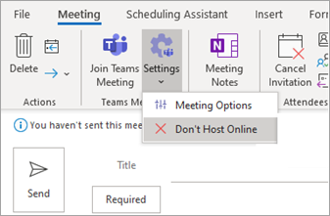

​​​​​​Outlook on the web
- In the new event form, select the Teams meeting toggle to turn it off.

Make all meetings Teams meetings
You can turn on a Calendar option so that all the meetings you schedule from Outlook—including Outlook on the web and mobile—will be held online with Teams.
Note: Depending on the release update schedule for your organization, you may not currently have access to this feature.

Outlook on the desktop
- At the top of the Outlook screen, select File > Options.
- On the Outlook Options page, select Calendar on the left.
- Under Calendar options, select Add online meeting to all meetings.
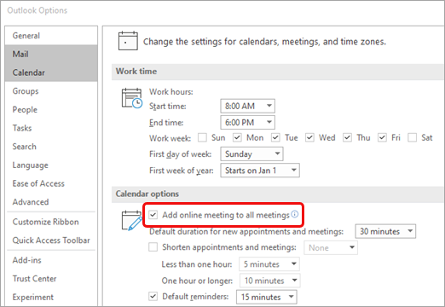

Outlook on the web
- At the top right of the screen, select Settings and then View all Outlook settings at the bottom right.
- Select Calendar > Events and invitations > Add online meetings to all meetings.
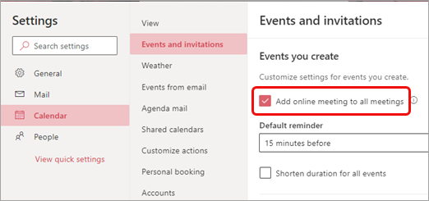
- Select Save.

End meetings early or start late
Outlook for Microsoft 365

If you're using Outlook for Microsoft 365, you can now have Outlook end your meetings a few minutes early or start late. This can help you build in travel time between meetings. You can choose a different duration for meetings under one hour and meetings over one hour.
- Select File > Options > Calendar > Calendar options
- Check the Shorten appointments and meetings checkbox and select End early or Start late depending on what you want.
- Use the drop-down to select the number of minutes for meetings less than one hour and one hour or longer, then click OK.
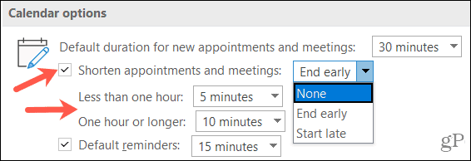

Outlook on the web users can set events to end early or start late by using the following instructions.
- Select Settings > View all Outlook settings > Calendar > Events and invitations.
- Check the Shorten duration for all events checkbox.
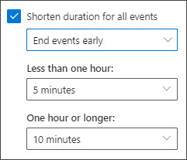
- Use the drop-downs to select the number of minutes for events less than one hour and one hour or longer, then click Save.
Once set, this setting will be honored across Outlook for Windows, the new Outlook for Mac, Outlook on the web, Outlook for iOS, and Outlook for Android.

NOTE for MAC users:
You can't currently set events to start late or end early from the new Outlook for Mac.

