Introduction

Welcome to the Partner Portal! This is a community of partners, hosted by the San Diego Workforce Partnership, that is open to members of the business services collaborative and other selected partners who share the goal of connecting job seekers with employers in the Southern Border Region of San Diego. Here are some key functions of the Partner Portal:
- Share job postings.
- Refer candidates to jobs.
- Share events and track RSVP and attendance.
- Collaborate with partners on areas such as resources, best practices, and employer engagement.

These functions allow us to improve our efficiency in the following ways:
- Access a larger candidate pool.
- Move from email communications to structured referral processes that promote better visibility and collaboration.
- Track referrals and outcomes at the individual and team level.
- Increase market penetration as we spend less time engaging the same employers and gain better insights into our current trends in industries and populations served as a collective group.

The following materials will serve as a guide to help you navigate this new system, so please feel free to use this as reference. If you have a question about a business process, we encourage you to ask a question on the community (see the Support section) so that others in the community who may have the same question can benefit from the answers you receive. If you have a technical error and would like to contact our Salesforce support team, please feel free to either submit a support ticket (see the Support section) or email SalesforceSupport@workforce.org.

Table of Contents
Introduction 1
Logging into the Portal 1
Jobs 1
Viewing All Job Records 1
Searching and Filtering Job Records 3
Creating New Job Records 6
Viewing My Job Records 8
Editing Existing Job Records 9
Referrals 10
Refer Your Candidate to a Job (Create a Match Record) 10
Match Approval Process 12
Approval Actions 12
Managing Your Pending Approval Requests 13
Events 13
Chatter 17
Tag People 20
Chatter Discussion groups 20
Topics 22
Chatter Topics 22
Record Topics 23
Featured Topics 23
Direct Messaging 23
Support 24
Business Support - Discussion Questions 24
Technical Support - Support Tickets 24

Logging into the Portal

In order to log in to the Partner Portal, please navigate to https://sdwp-jobs.force.com/Partner/. You will enter your username and password and click the Log in button to access the site.

If you do not currently have login credentials, please click the link that says Need an account? Request one here! This will submit a request for an account to the San Diego Workforce Partnership for review, which should be completed within 10 business days. If you have not received instructions on next steps for accessing the Partner Portal after this time, please contact Business@workforce.org to verify the status of your request.

If you forget your password, you can click the Forgot your password? link to have Salesforce send you a self-service link to reset your password. If you do not receive this email within 10 minutes of submitting the request for a reset link, then you either do not have an active account or there is a technical error. For help troubleshooting this error, please email support at SalesforceSupport@workforce.org and describe the issue you are experiencing.

Jobs

Viewing All Job Records
In order to create a Job record on the Partner Portal, you must navigate to the Jobs tab using the navigation menu.
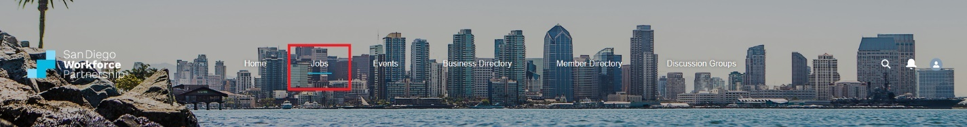

Once you have navigated to the Jobs page, you will see several tabs relating to Jobs, Matches and Hires in the body of the webpage. The first tab, titled Jobs, will be selected by default, and in this tab you will see a list of Job records under the list view titled Open Jobs.

In order to open one of these Job records, click on the Job Title, which will be the first column in this list.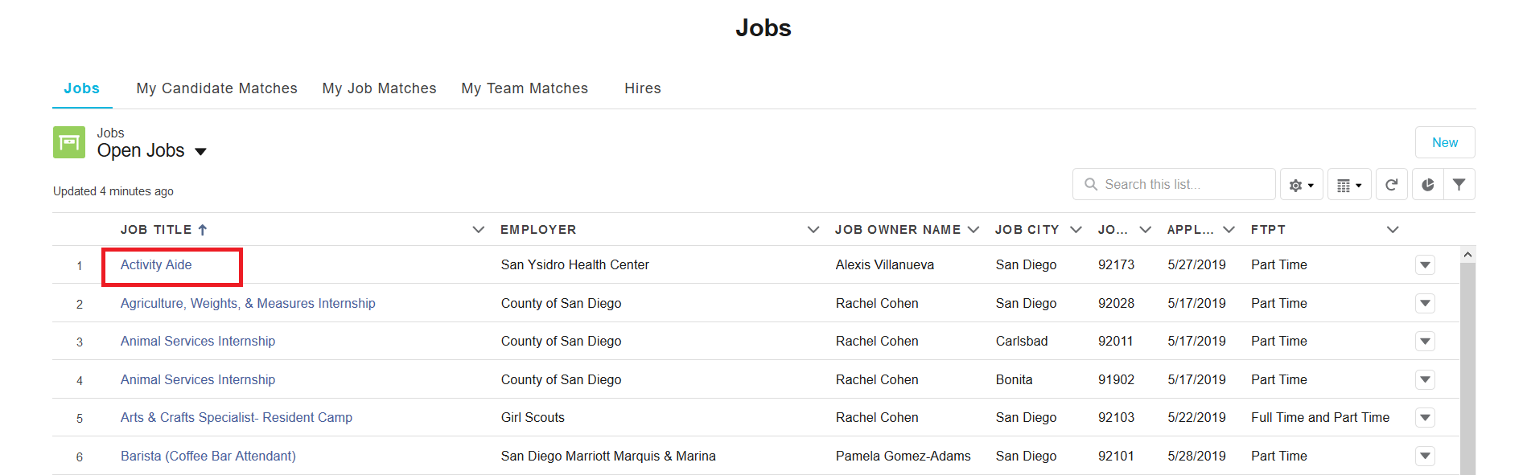
After you click on the Job Title, it will open the job record in a page titled Job Details, and this will display all of the relevant details of this job on the center and left side of the page as well as action buttons at the top right of the page and related Hires and the record Chatter feed on the right side of the page.

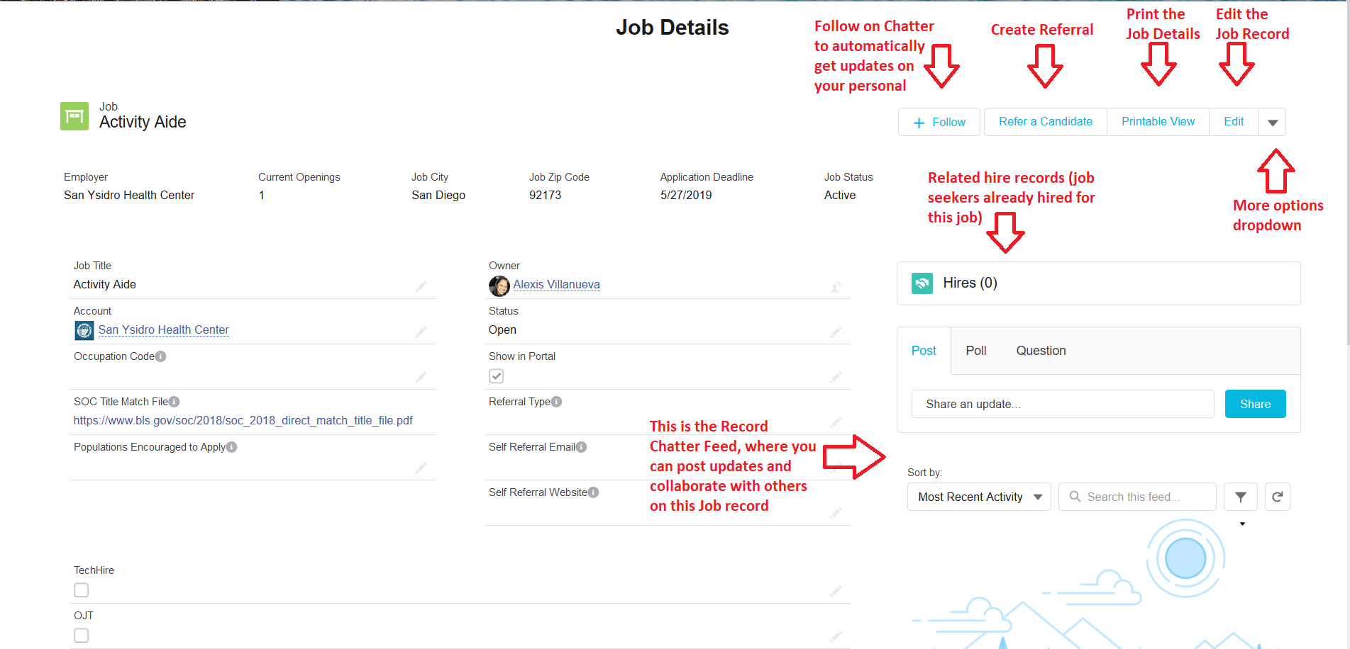

In the Job Details, you will see several sections that can be expanded by clicking on the section heading. For example, in the image below, the first section heading, Matches and Hires, is expanded, while the others are collapsed.
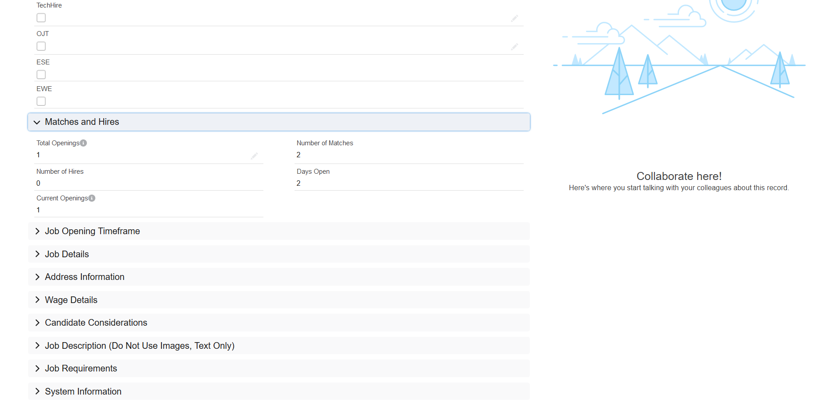

Searching and Filtering Job Records
In order to search for a job record, you can use the List View Search at the top of the Jobs list on the Jobs page. If you are unsure how to navigate to this page, please review the previous section on Viewing Job Records. This search bar will search most fields on the Job, even beyond what is shown in the list, to show you relevant search results in the list below. In order to perform a search, click on the search bar, enter your search term(s) and hit enter on your keyboard. In the example below, we have searched for the word Cashier, which returned 6 results.
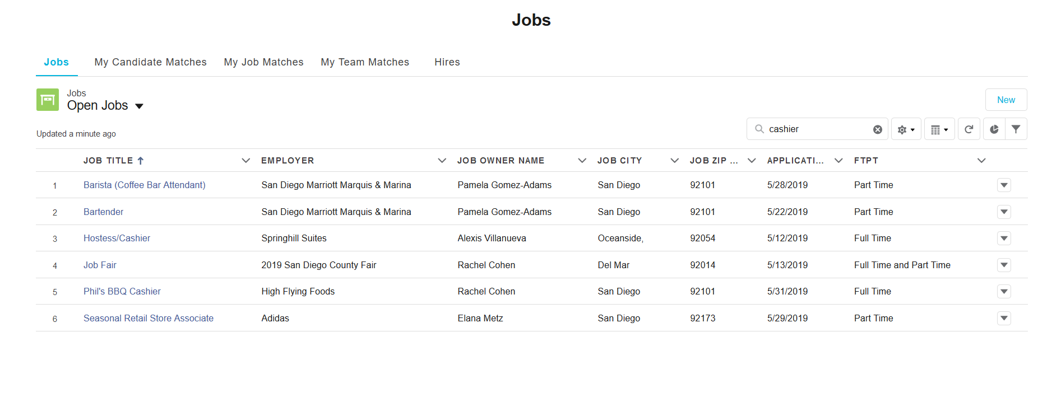

In order to perform a more robust search of all Jobs in our Salesforce database, you can also use the Global Search, which is located at the top right of the page header as a magnifying glass icon.
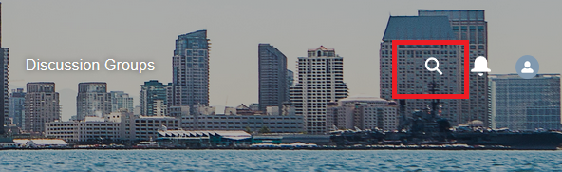

Once you enter your search term into the Global Search, it will populate a limited set of search results in real time in a window under the search bar, as seen below. If you do not see any immediate results based on your keyword, you can perform a full search by hitting enter on your keyboard.
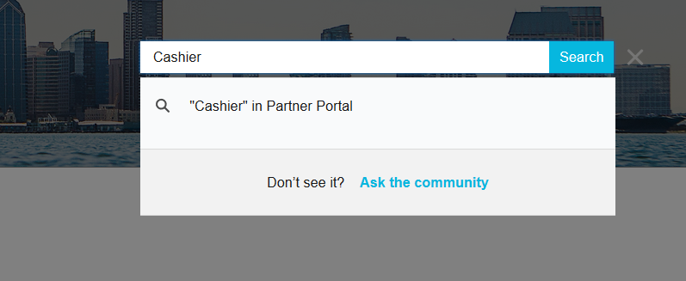

Once you hit enter, you will be redirected to a search results page, where all relevant Salesforce Job, Account, Event, and Discussion & Topic results will show, based on your search terms.

Below, we can see that 5+ jobs are shown based on the search for the word Cashier.
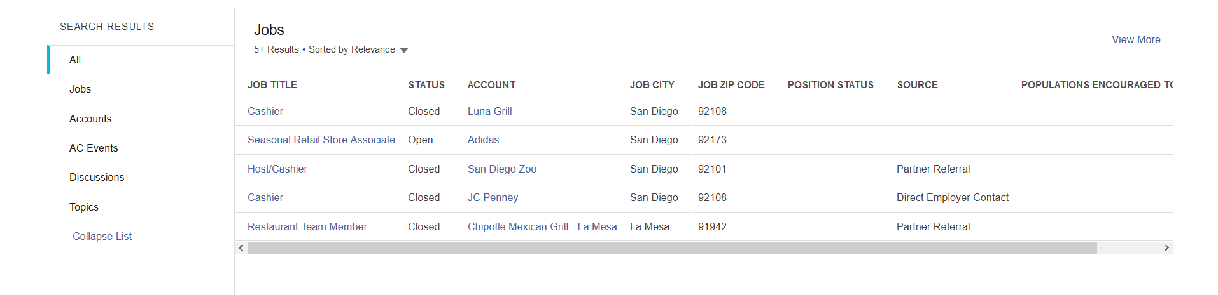
Since there are more than 5 Job records found that are related to that search term, you can view all of the results for this search by either clicking the View More link at the top right of the search results or by clicking the Jobs tab on the left side of the search results under All. When you perform either of these actions, you will be shown the full list of relevant jobs based on your search term(s), as seen below.
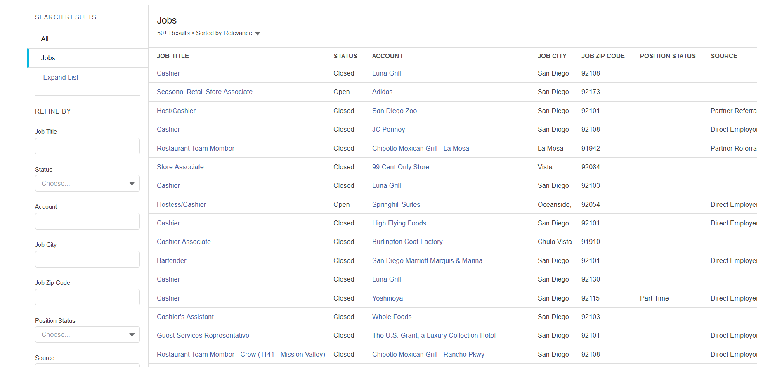

You can choose to Filter these search results by using the fields on the left side of the search results screen under the words Refine By, further narrowing your results. One important consideration when searching for records using the Global Search is that you will see all records stored in our Salesforce database, not just those shown in the Jobs list on the Jobs page. This will include Jobs that are outdated and closed. Therefore, it is important to properly filter your results when using this powerful search feature so that you are getting the desired results.

In the case of Jobs, using the Status filter will allow you to only view jobs that are currently Open to applications, rather than closed, as shown below.

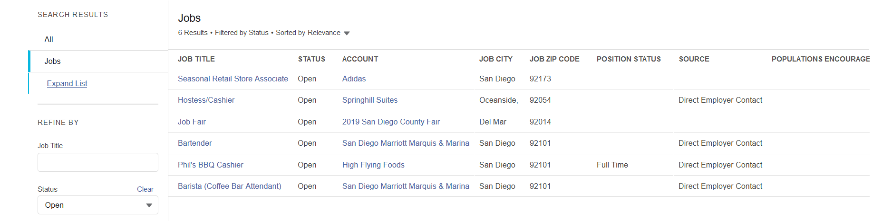
Please also note that Global Search will search all fields on a job record, including the job description, address, education required, and any other field you can see when you open a job record. For example, the Bartender position above does not have the search term, Cashier, in its title, but you will find if you open the Job record that the word Cashier can be found in its job description.

Creating New Job Records
In order to create a new Job record, navigate to the Jobs page by clicking on the Jobs navigation menu item at the top of the page. Locate the button that says New at the top right of the list of Jobs and click that button to begin the process of creating a new job listing.
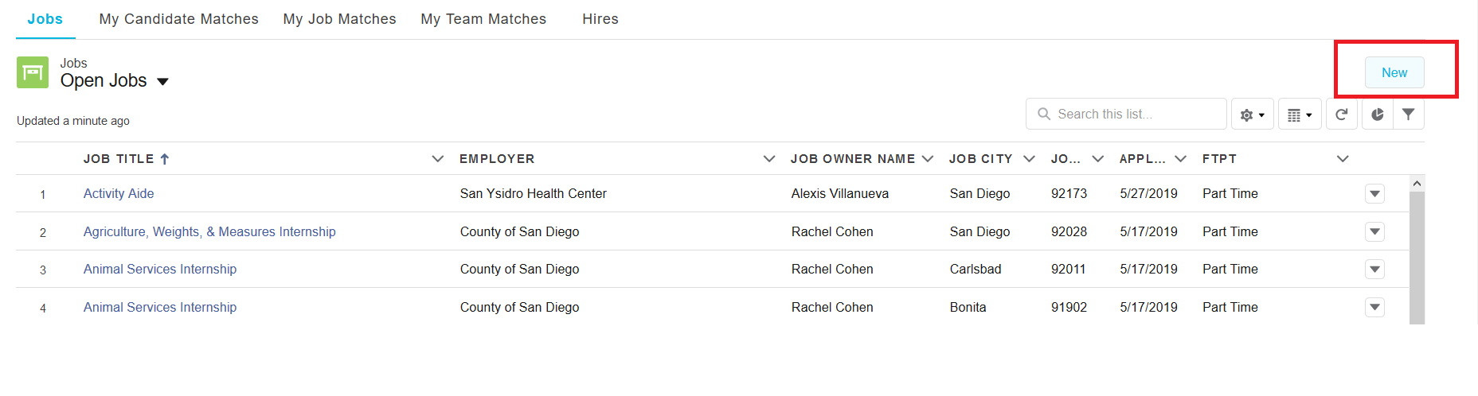

Once you click the button, a window will open that allows you to enter information to create a new job listing. Required fields are marked with a red asterisk (*) to the left of the field name, as show in the image below.
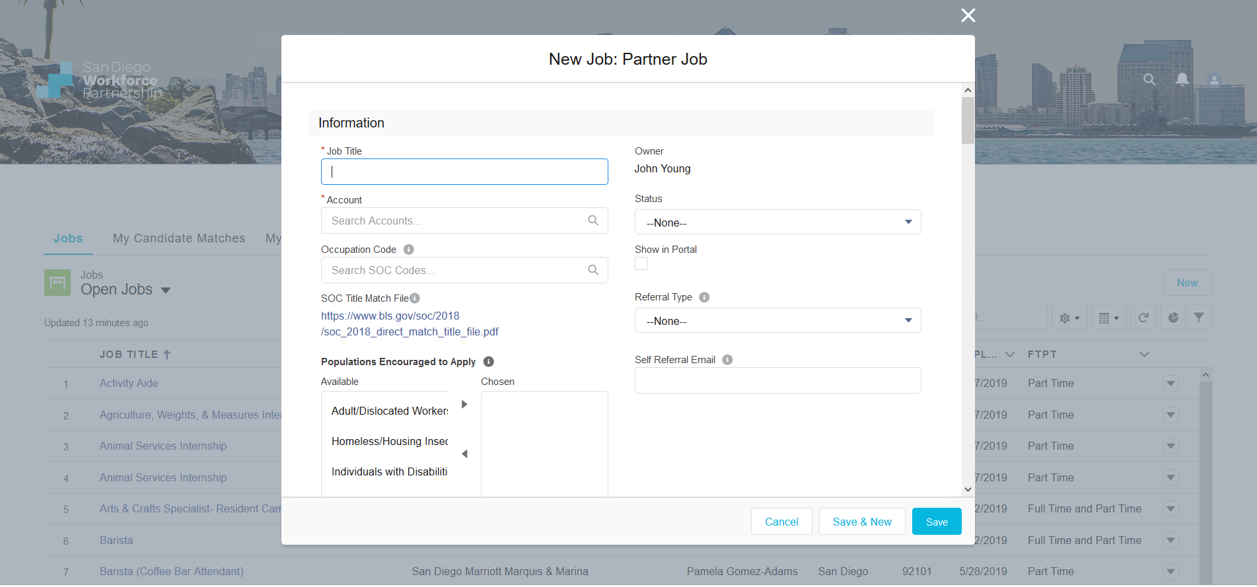

The fields that you are required to fill in order to save a new job listing are:
- Job Title
- Account – the business name of the employer.
- Total Openings – number of open positions they are wanting to fill.
- Job Type
- Position Duration
- FTPT – acronym for Full Time or Part Time.
- Job Address – street, city, state, and zip code.
- Career Level – entry, early, mid, or late career are the choices, referring to how much experience the employer anticipates a candidate should have when applying to this job.
- Years Experience
- Education Required – this may also be used to show what education level is preferred by the employer, rather than a hard requirement.
- Job description

There are also a couple fields we strongly recommend completing:
- Show in Portal – this determines whether the job shows to other partners and job seekers. If you forget to check this box, it will automatically be checked for you by an automated workflow, but we recommend checking it manually. If your job listing has this checkbox unchecked, it will not show in the Open Jobs list view, and you will need to instead view it in the My Jobs list view by clicking on the list view dropdown menu. For more information on viewing this list view, please refer to the next section in this guide, Viewing My Job Records.

- Application Deadline – this is the date when you would like to stop accepting applications from job seekers, and it will automatically uncheck the Show in Portal checkbox 1 day after the application deadline date to remove it from being viewable by other partners and job seekers to prevent them from continuing to refer candidates.

- Closing Date – This is a date you can specify when the job listing will automatically change its status from open to closed. If you leave this blank, it will automatically be set for 30 days from the date you create the job listing. On this closing date, your job will discontinue to be listed in the Partner Portal and the status will automatically be closed.
  - When a job is marked as closed status, it means that the employer is no longer accepting referrals. This is different from the application deadline, which simply removes the job listing from public view and thus prevents more candidates from being referred to the BSR, who can then use the time between the application deadline and the closing date to compile and refer their top candidates to the employer.
  - If you wish to keep the job open for longer than 30 days, change this date to a later date when creating the job listing or by editing this field after the job has been created.
  - If you realize that your job has closed as the result of the closing date but you would like it to remain open longer, you will need to (1) change the Status field from closed to open and (2) check the Show in Portal checkbox to show the job listing to partners and job seekers.

Viewing My Job Records
If you want to view all Job records that you have personally created, you must first navigate to the Jobs page using the navigation menu. You will see underneath the Jobs tab that there is a dropdown menu that has the list view Open Jobs selected by default. Click on this menu to bring up other options (shown below), which include My Jobs, where you will find the jobs that you have created. The list view Recently Viewed will show all job records you have recently opened.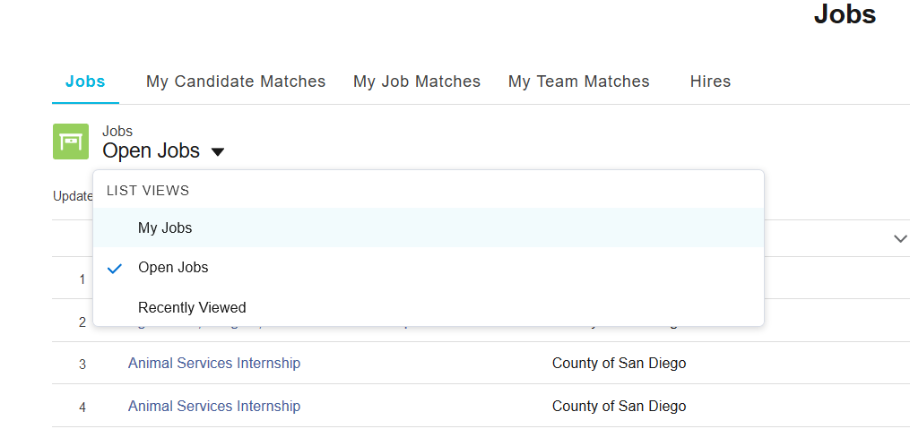

Editing Existing Job Records
You will have the ability to edit your existing Job records. In order to view Job records you have created, navigate to the My Jobs list view (for more information, please see the previous section, Viewing My Job Records).
Please Note: If the My Jobs list is empty, then that means you have not yet created any job records.
Select the job you would like to edit by clicking on the Job Title. Once the record has opened in a new page, either click on the Edit button at the top right of the page or click on the pencil icon next to the field you would like to edit, as shown below.
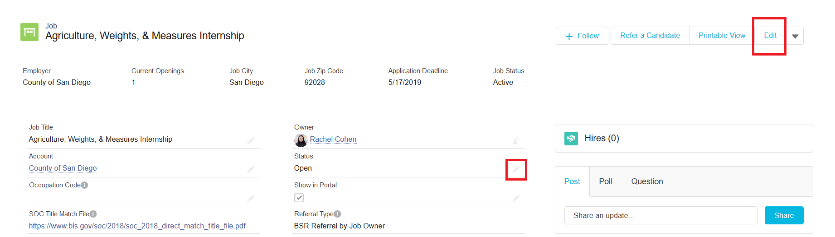
Once you have made your desired changes to the record, you must click the Save button at the bottom of the page in order to save your changes.

Referrals

Refer Your Candidate to a Job (Create a Match Record)

In order to refer one of your candidates to a job:
- Open the Job record that you want to refer your candidate to.
- Click the Refer a Candidate button at the top right of the record.
- Fill in the required information - Name, Date of Birth, Email, and Reason for Referral.
  - Reason for Referral – this should explain why you feel your candidate is well suited to this particular job.
- Upload your candidate’s resume (if you don’t have it, you can upload it later).
- Click finish to complete the process.

Once you complete this process, the system will create a Match record and will route it for approval to the Case Manager (if applicable) and Job Owner for review. On the next page is the standard process for how this Match record will be routed.
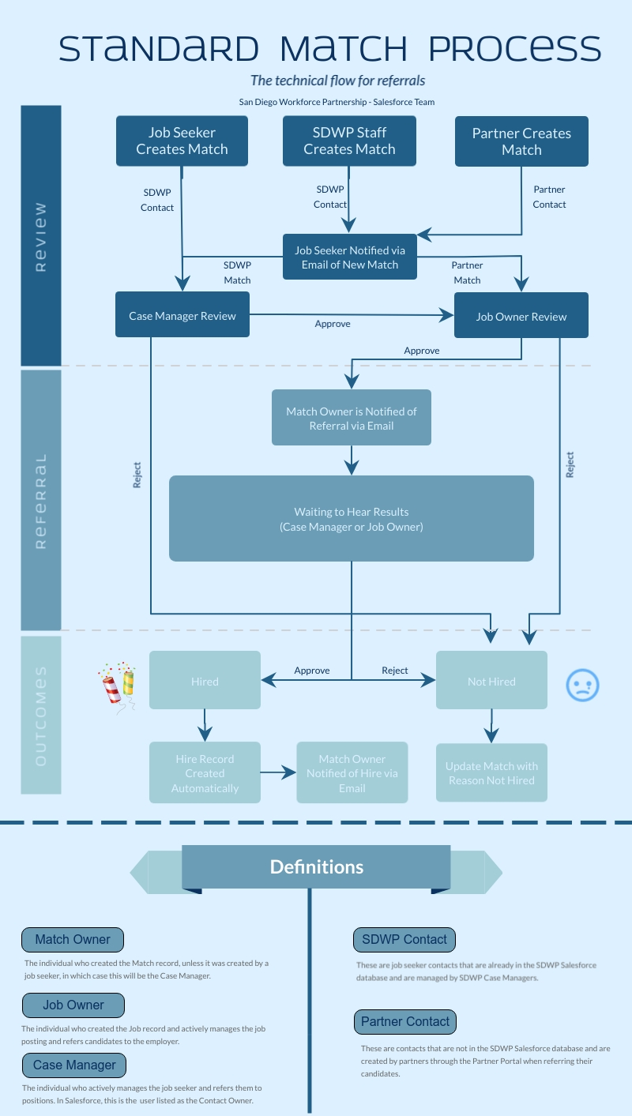

Match Approval Process
When the Match record is created by referring your candidate, it will automatically enter an approval process (shown on the previous page). For each step of this process, the assigned individual, or approver, must approve the candidate in order for the Match to continue to the next step. If the approver rejects the record, the process will end and the status of the Match will be moved to “Not Hired,” which signifies that the candidate was not hired for the position. Here are the approval process steps and what they mean:

- Case Manager Review – A SDWP case manager reviews the candidate's qualifications and eligibility to determine if they are a good fit for the position. This step is only applicable when SDWP staff create a match or if a job seeker creates a match through the Career Portal. Matches created on the Partner Portal will not enter this step.
- Job Owner Review – The job owner is listed on the job record and is the individual who created the job record, by default. This person will review all matches for their job and will choose which candidates to refer to the employer.
- Waiting to Hear Results – This status applies to both the case manager and job owner, either of which may approve a record in this stage based on whoever hears whether or not the candidate was hired.
- Hired – This status reflects that the candidate was hired, and a Hire record will automatically be generated and linked to the Match record when this status is reached.
- Not Hired – This status reflects that the candidate was not hired, and the match owner will be encouraged to update the Match with more information on the reason they were not hired in the Reason Match Closed field.

Approval Actions

Approve: This means that the candidate will move to the next status in the approval process.

Reject: This means that the candidate will not move forward in the hiring process and the Match will reflect the Not Hired status.

**In the approval email you receive as the assigned approver for a Match, detailed instructions will be provided concerning each of these statuses and what actions you are expected to take.

There are several email notifications associated with this process that are sent automatically based on whether the Match record is approved or rejected. These are listed below and are also reflected on the flow chart on the previous page.
- Approver Email: This is sent to whoever the assigned approver is for a certain approval process step (see above for the 5 steps in this process).
- Match Owner Notification: The Match Owner, who is usually the individual who created the Match, will be notified:
  - When the candidate has been referred to the employer.
    - This occurs when the Job Owner approves the Match and it moves to Waiting to Hear Results.
  - When the candidate has been hired.
- Job Seeker Notification: The job seeker will be emailed when the Match is first created (at the email address you provided when creating the Match) to let them know that they have a new Match.

Managing Your Pending Approval Requests
It is possible that you may receive multiple approval requests for Matches if you have listed a job on the Partner Portal. While there is currently a plan to create a consolidated list of your pending approvals in the future, this feature does not yet exist and may take some time to develop.
In order to organize your approval request emails, we recommend creating an Outlook folder and automatically routing these requests to that folder. This will allow you to organize your approvals based on which are still pending and which are approved/rejected so that you know which ones you still need to take action on. While this is by no means mandatory, it is important to track these email requests so that you do not miss the opportunity to refer a qualified candidate to the employer.

Events

The Partner Portal hosts an event management system that lists events created by SDWP staff and partners for the purpose of advertising these events to other partners and tracking their attendance. In order to navigate to the Events page to view these events, select the Events tab on the navigation menu.

Once you have navigated to this page, you will see a calendar an event calendar and list on the left side of the screen and a button to create a new event with a list of previously created events on the right side of the screen, as show below.

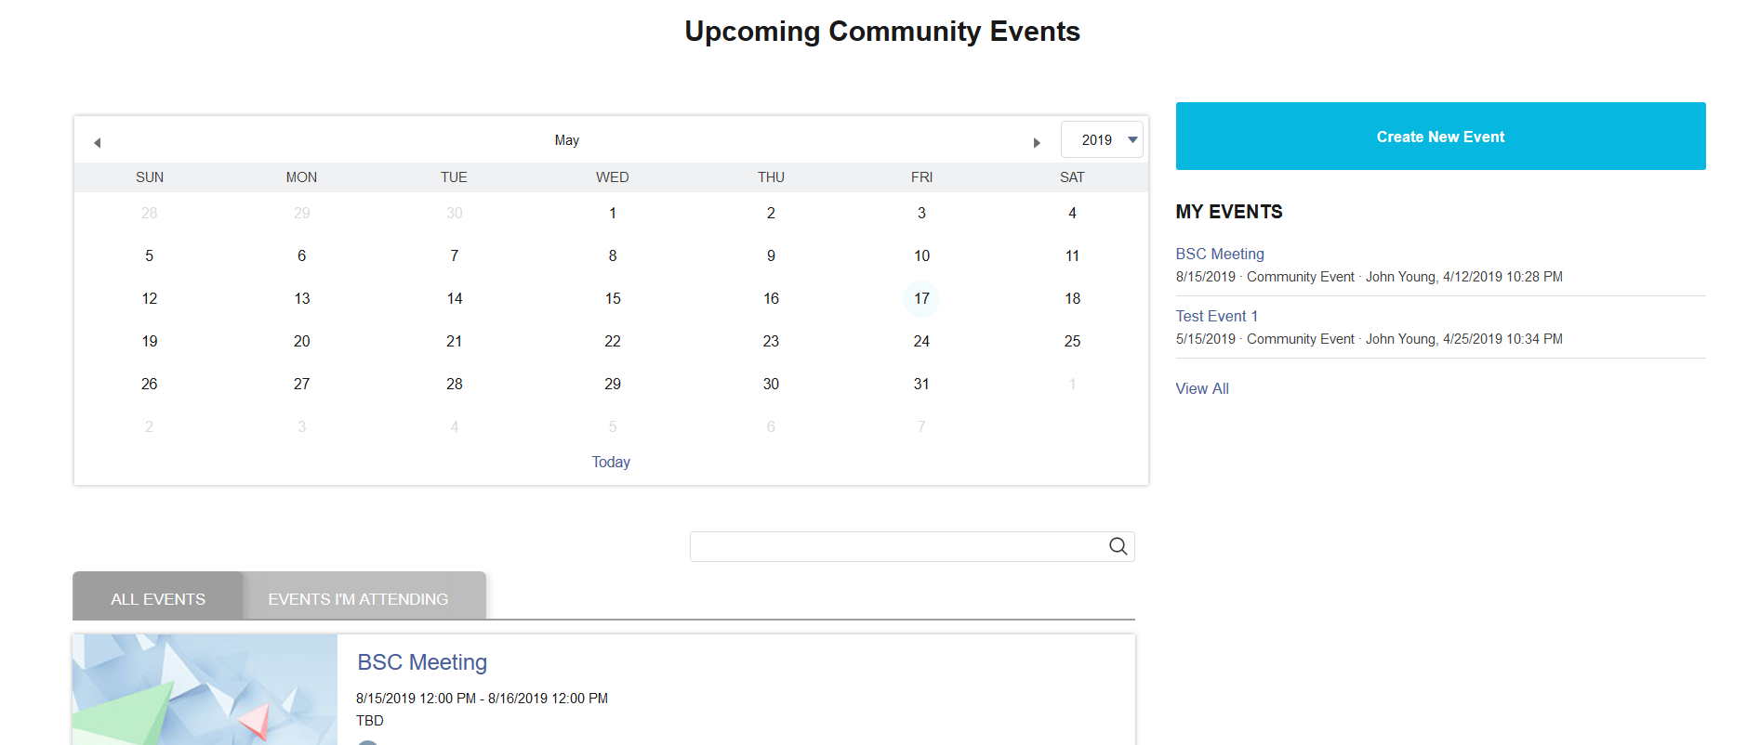

The calendar will have certain dates highlighted if there is an event listed on that date. In order to view all events for that date, simply click on the date on the calendar.

The list of events shows events that members of the Partner Portal have created, and you can RSVP to these events by clicking on the Going? button and selecting either Going or Not Going (as shown below), and this status will then be reflected when you view that event on this list in the future.

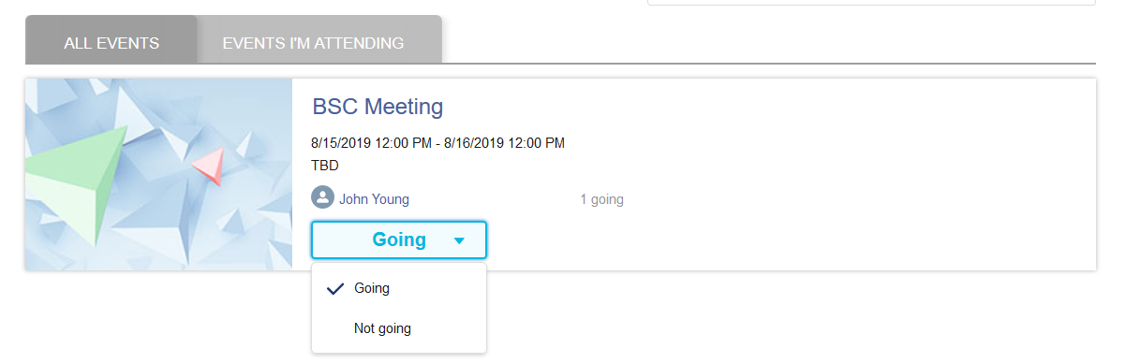

In order to create your own event, click on the button labeled Create New Event. You will be prompted to fill in a series of fields (shown below):

- Event Name
- Venue Address
- Start & End Dates
- Event Organizer (if applicable)
- Event Partner (if applicable)
- Trainer (if applicable)
- Limit of attendees
  - This is the maximum number of attendees you would like to be allowed to register for this event through the Partner Portal. Leave this as 0 if you do not want there to be any limit, as this will allow unlimited registrations.
- Description

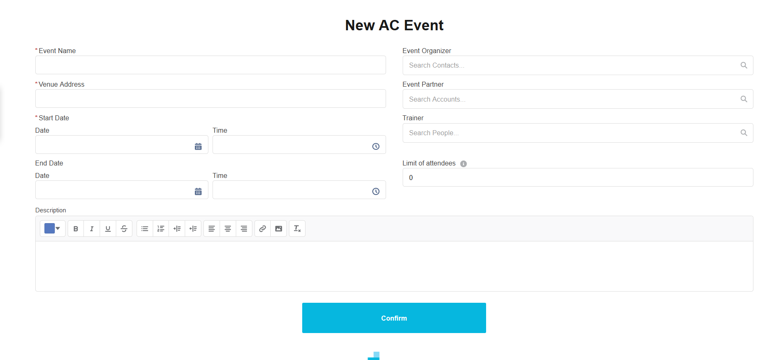

Once you have filled in these fields, click confirm, and you will be redirected to the record detail page of your new event, as seen below.

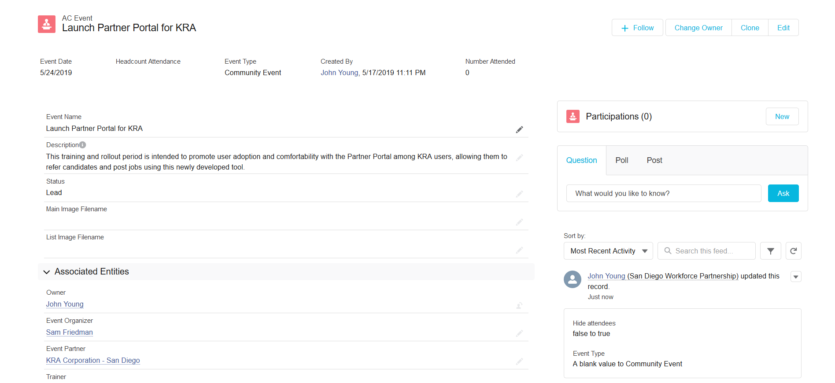

On the right side of this screen is your participations, which are automatically created whenever someone RSVP’s that they are Going to your event on the events list. The event attendance numbers are automatically generated based on these participation records as follows:

- Number registered – this is the number of participation records created for your event, based on how many people RSVP’d, or registered, for your event.
- Number attended – this is based on the number of participations where you have checked the Attended checkbox. Click into a record under the Participations tab to view and edit this checkbox.

Once you navigate back to the Events page, you should now see your event in the list of all events as well as on the right side of the screen underneath the Create New Event button in a list titled My Events.
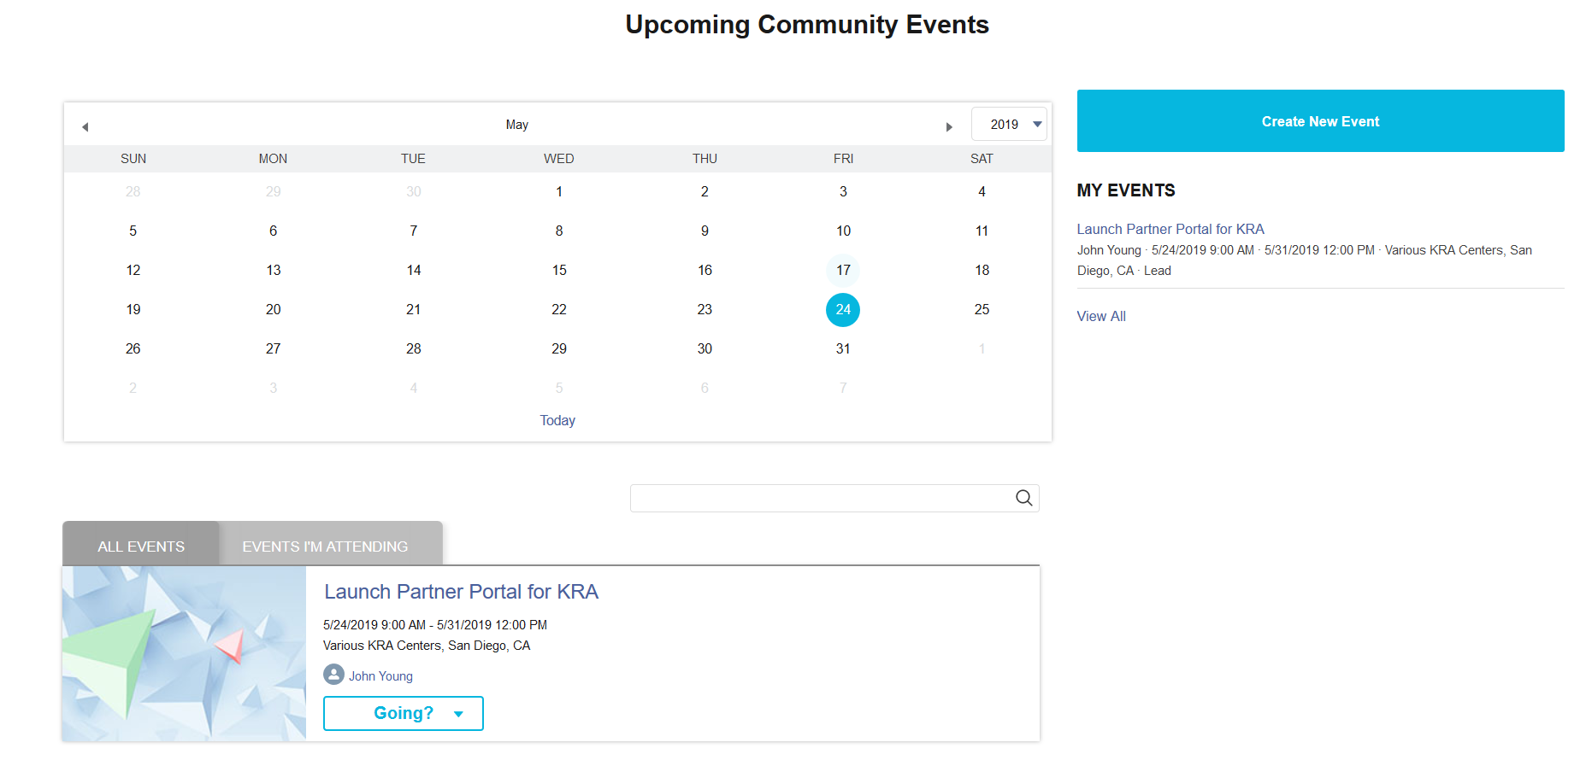

Chatter

Chatter is a chatting function that allows you to tag people and records when making comments, fostering collaboration and efficient communication. A Chatter feed is a window that displays Chatter comments, with the newest comments at the top. There are two types of Chatter feeds:

- Your home page Chatter feed
  - This has updates on records that you +Follow and comments that you are tagged in.
  - When you comment on this Chatter feed, the only way others will see your post is if you tag people or if other Partner Portal members are following you, which you can see in your User Profile.
- Record Chatter feed
  - Any Chatter feed that is located on a record, whether it is a Job, Event, Match, etc.
  - When you comment on this type of Chatter feed, it will automatically be linked to the record it is associated with.

Chatter feeds are sortable, filterable, and searchable, giving you easy access to whichever updates are most important to you.

Home page Chatter Feed:
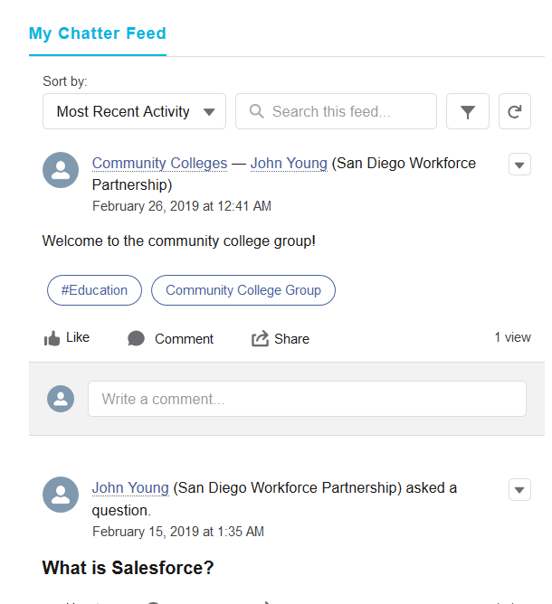

Record Chatter Feed:

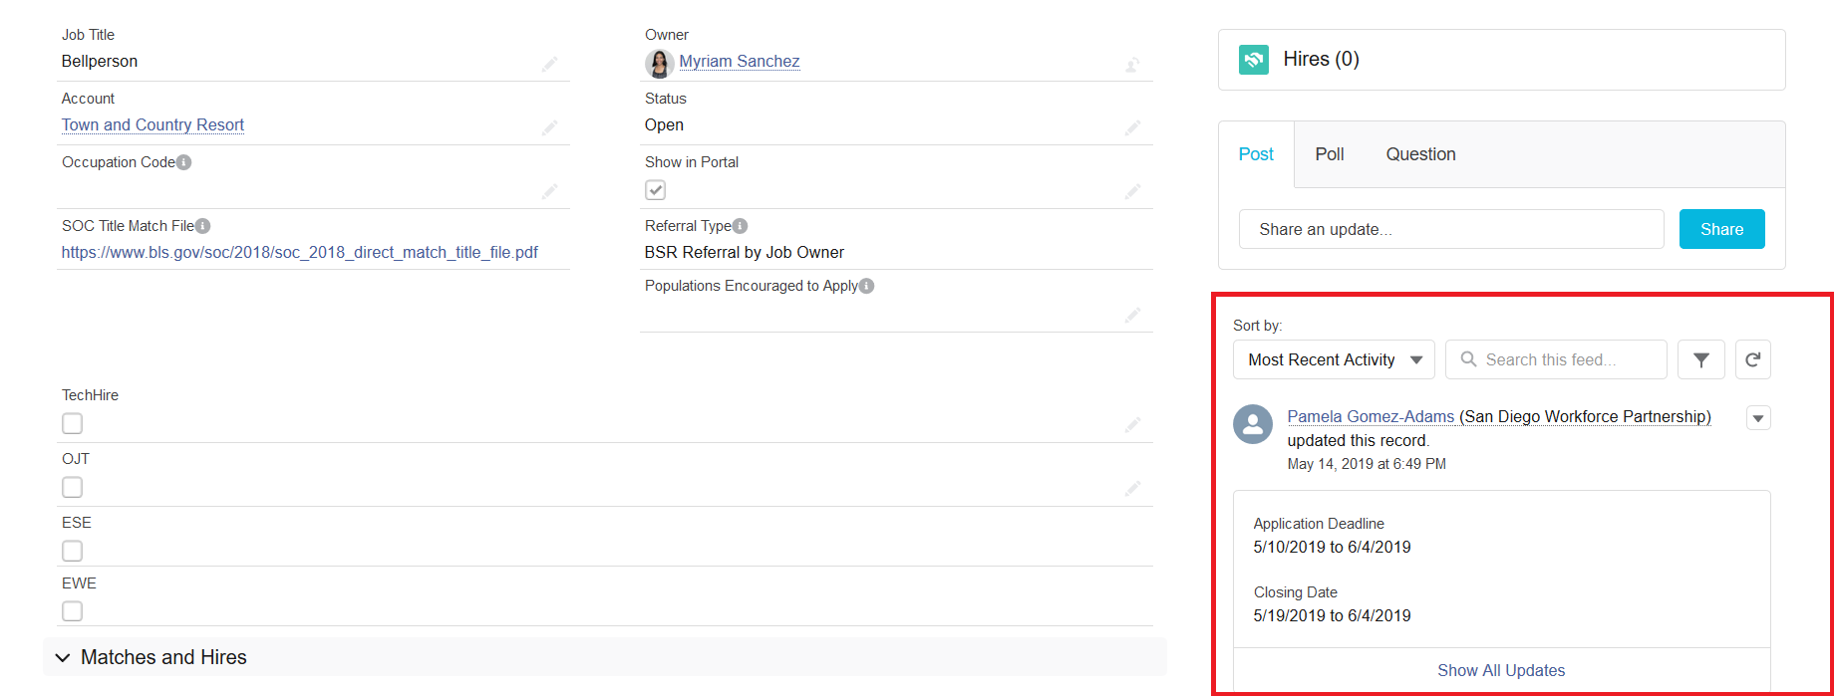

You will generally want to use the Post function on Chatter to post comments, but you can also use the Poll and Question functions to meet your needs, as shown on the next page. Poll results will show up anonymously, which makes it helpful to gather feedback from staff, while questions can help others who might have the same question find the best answer quickly.

Poll Example:
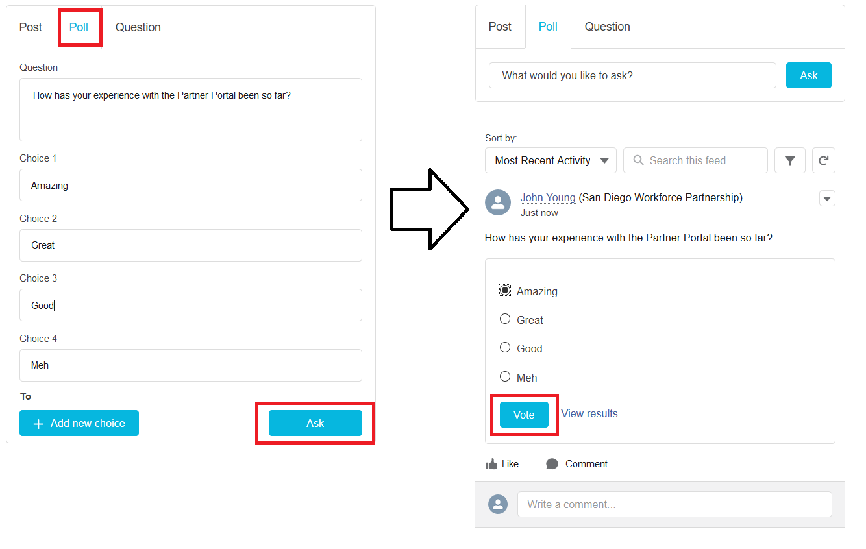
Question Example:
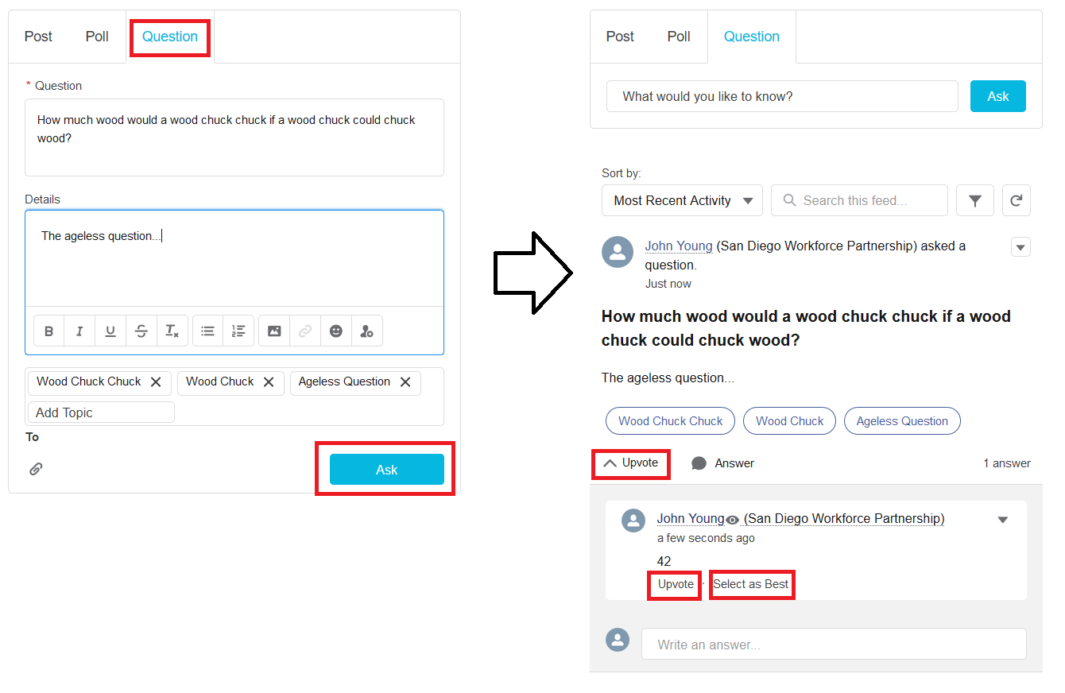

Tag People
In order to tag another person in a Chatter post, use the @ symbol. Once you type @ and begin to type someone’s name, it will offer suggestions, and you can click on the person you are trying to select once you see them show in that dropdown dialog window, as shown below:
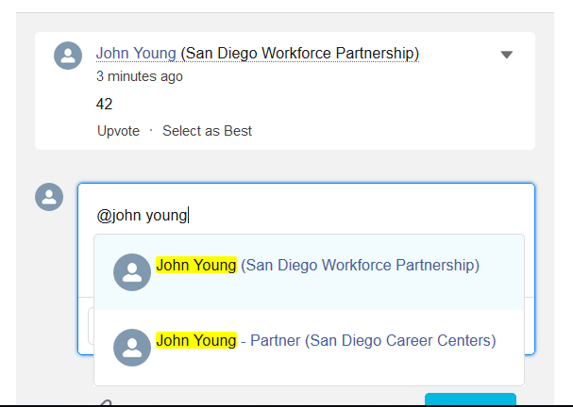
Tagging another person notifies that individual via email, showing the comment and allowing them to directly open the location of that comment from their email. You can also tag a Chatter Discussion Group using the @ symbol, which will populate your post in the main discussion group Chatter feed; this can be useful for collaboration on a particular issue or record.

Chatter Discussion groups

There are also Chatter Discussion Groups that are set up to foster collaboration within certain teams.
In order to see all active, public groups, click on the Discussion Groups navigation menu tab, which will take you to the Groups List page. From here click on the list view on the top left of the page to select the Active Groups list.
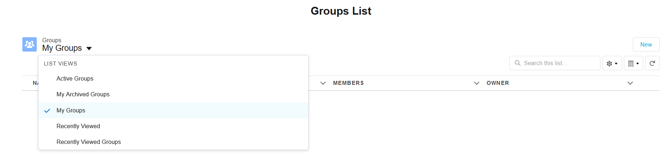

In each group there is a Chatter feed where members of the group (or non-members if the group is public) can post messages to the group. Group members can post to the Chatter feed via email by using the Group Email listed under the Group Details section; any text that is sent to this email address will be posted as text in the Chatter feed of the group.
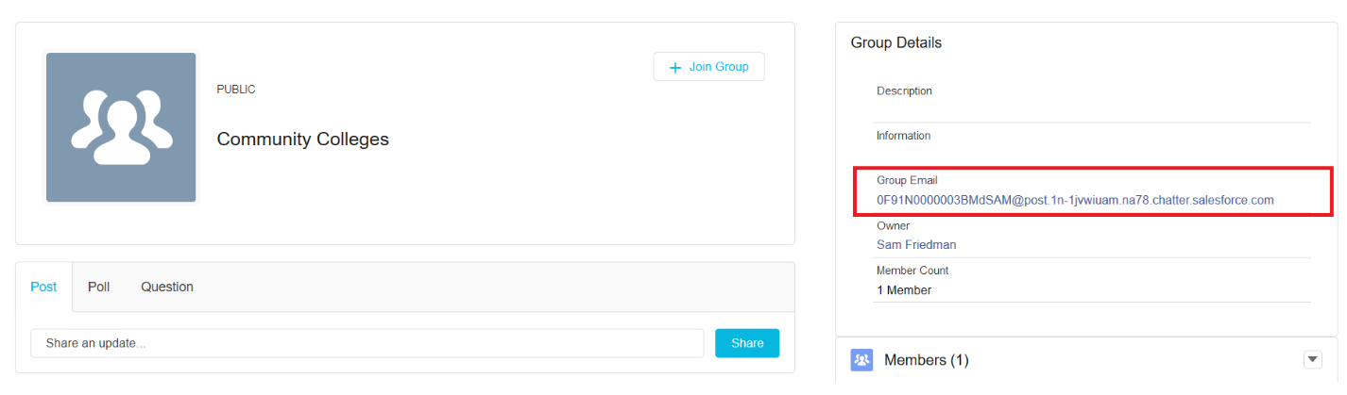

In order to create a new group, navigate to the Groups List page and click the New button at the top right of the list view, fill out the group details, and click save.
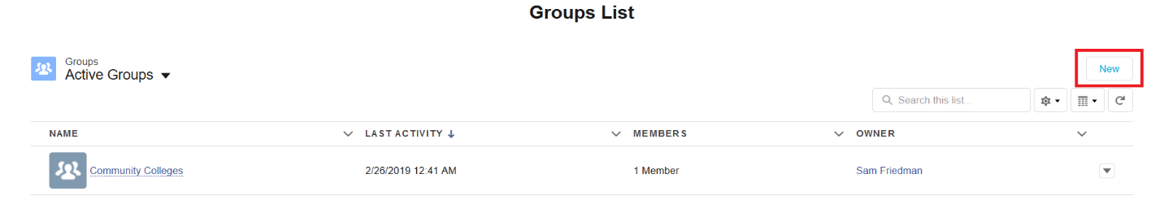

You can share Files in Chatter Groups by navigating to the group detail page and either attaching the file to a Chatter post or uploading it in the Files tab on the right side of the page under the Members tab.
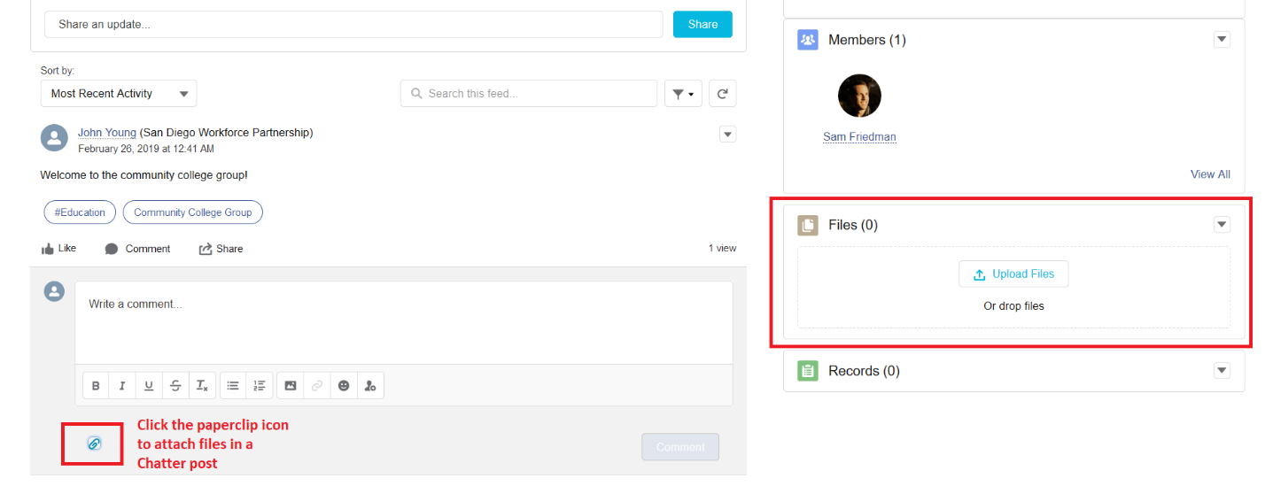

Topics

Topics are useful for grouping records and Chatter posts through the use of topic tags. You can click on a topic to access other Chatter posts and records that have been tagged under the same topic.

Chatter Topics
You can add a topic to a Chatter post at the bottom of the Chatter post window, as seen below. Often recommended topics will automatically populate on your posts based on its wording content.
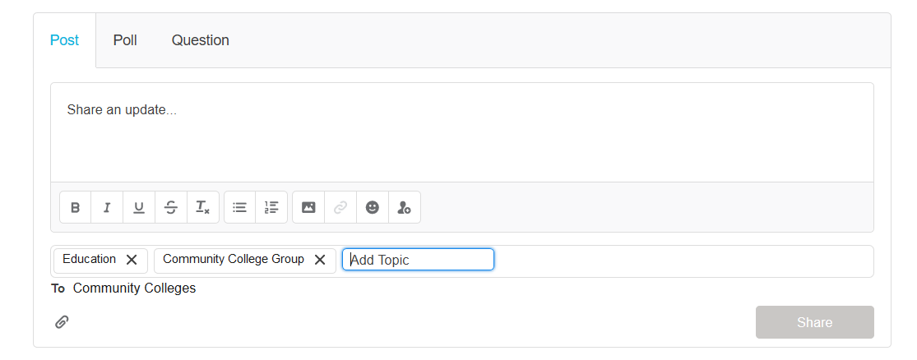
In order to add a topic to a reply comment, use a # followed by your topic tag.
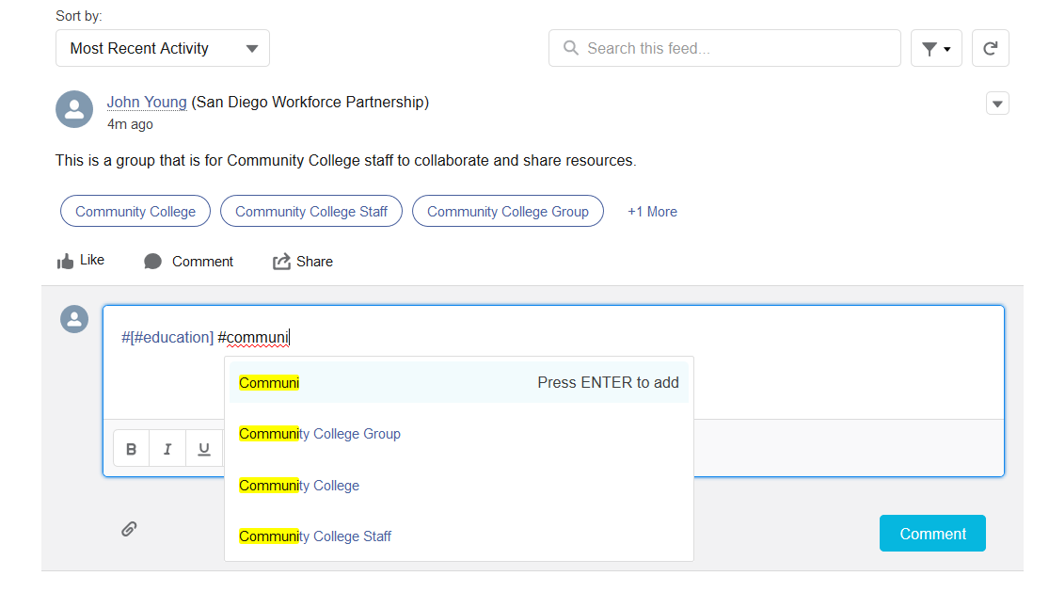

Record Topics
Just as you can add topic tags to your Chatter posts to group them together, you can also do so for records under the Topics tab. You are able to assign up to 100 topics to a single record. When you click on one of the topics, it will take you to the topic discussion page, where you can see other posts that have also been tagged with that topic.

Featured Topics
These are the primary topics on the Partner Portal, and they are shown on the home page in order to encourage communication on their respective subjects. When you click on each one, it will direct you to the discussions surrounding that topic.

Direct Messaging

In order to communicate directly with other members of the Partner Portal, you can use direct messaging. Recent messages can be seen on your home page, and you can also create messages from here directly by clicking on the New button next to Recent Messages, as shown below.
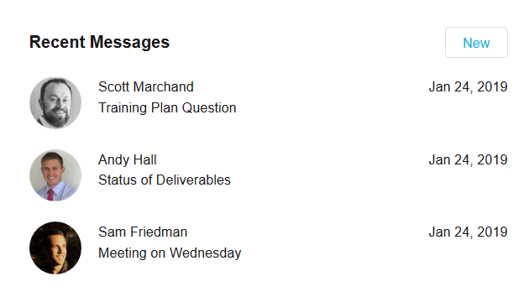
You are also able to add or remove people from a conversation, allowing you to maintain a private conversation but do so with a group of other people. This can be accomplished from the message screen, which is opened when you click on a message.
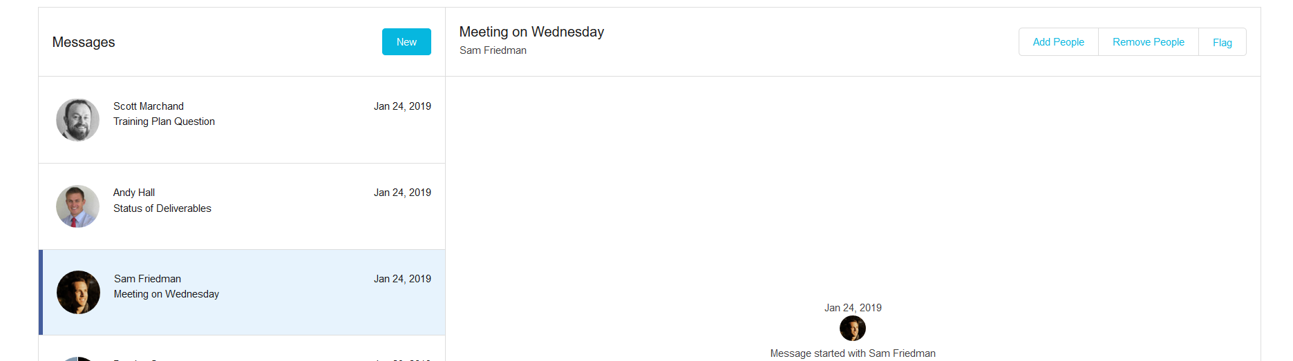

Support

Business Support - Discussion Questions

In order to address business related questions, there are a couple of different support options. First and foremost, we encourage members of the Partner Portal to pose their question to the community, tagging topics and individuals as desired to get the attention of others. This is a good practice because it allows other current and future members of the community to also find the answer to your question, and this practice will therefore promote institutional knowledge and partner collaboration.

The second support option is to email Business@workforce.org, which will put you in touch with the San Diego Workforce Partnership business services team. This is for questions that either require urgency or are too specific or private to ask the community.

Technical Support - Support Tickets

In order to receive technical support, there are once again two options. The first step to both is to click Contact Support on your profile menu, which will take you to the Contact Support page.
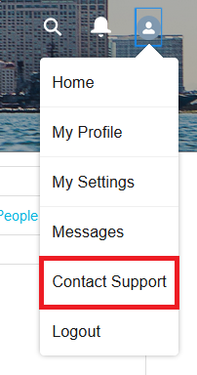

From this page, we recommend using the Ask a Question button for issues such as ‘how to create a referral’ or ‘where to access resources’, since these are technical questions but do not necessarily require dedicated technical support, and there may be others who can benefit from the answers you receive to these questions from the community.

For immediate technical assistance when encountering errors, please create a support ticket by navigating to the lower half of the Contact Support page and clicking the Create a Support Ticket button.

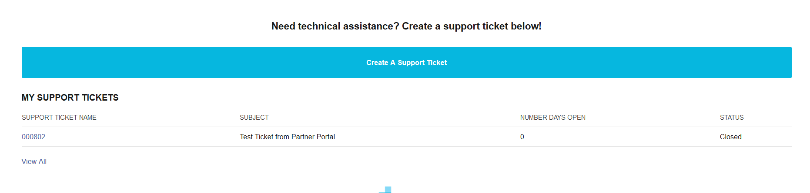

From here you will be prompted to answer a few questions, after which a support ticket will be created and will be shown in a list underneath the button. If you have any difficulty in creating a support ticket by this means, such as if you are not able to log into the Portal, then please contact support at SalesforceSupport@workforce.org instead. Please do not create a ticket AND send an email, as this will unnecessarily create duplicate support tickets.

