Salesforce Agreement Process DocuSign Steps to Send Documents
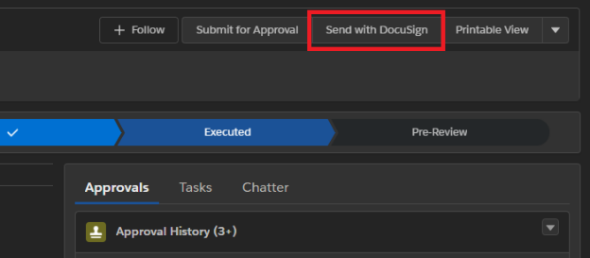
Step 1. Click Send with DocuSign Button

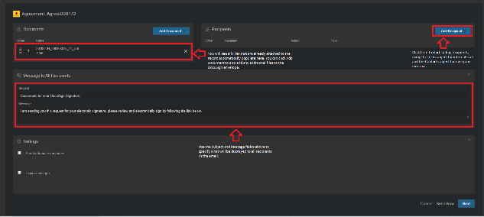
Step 2. Add Documents, Recipients, and Email Message

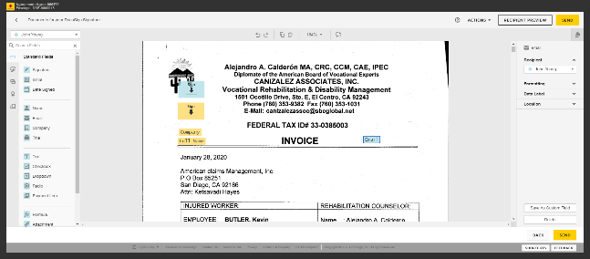
Step 3. Add signature & merge fields, review, and send

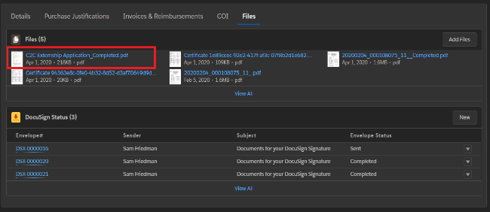
Step 4. Once document is signed by all recipients, it is automatically emailed to the Sender and all Recipients, and it is also attached to the Agreement record.

Detailed instructions can be found in this Salesforce knowledge article.

