Configure Salesforce Personal Settings
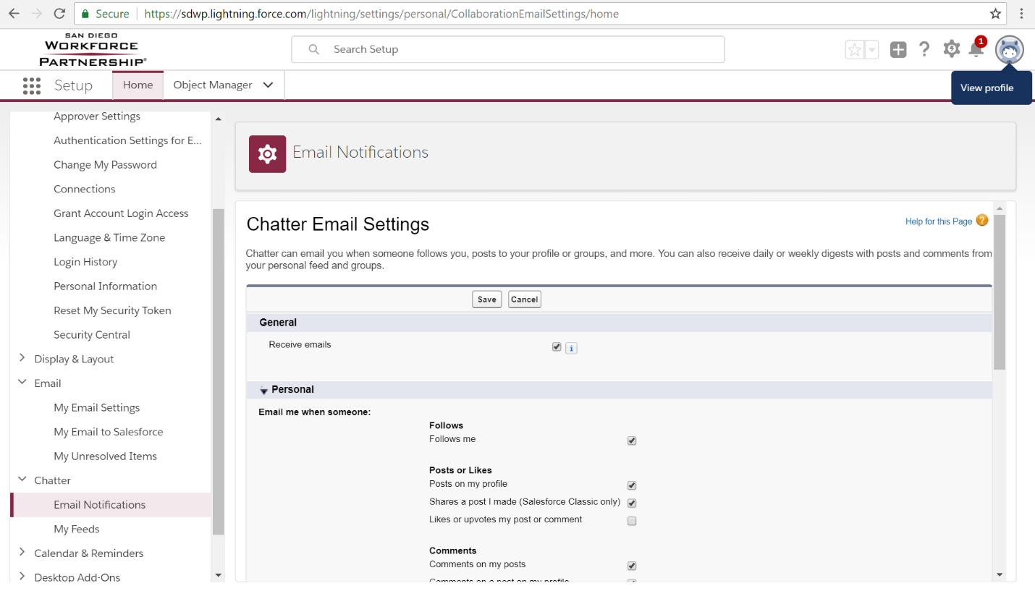
Figure 1. Access the Profile Menu by clicking on your avatar or picture icon, which will give you the options of Settings, Log Out, Switch to Salesforce Classic, and Add Username. To access the Personal Settings Menu, you will click the Settings link.
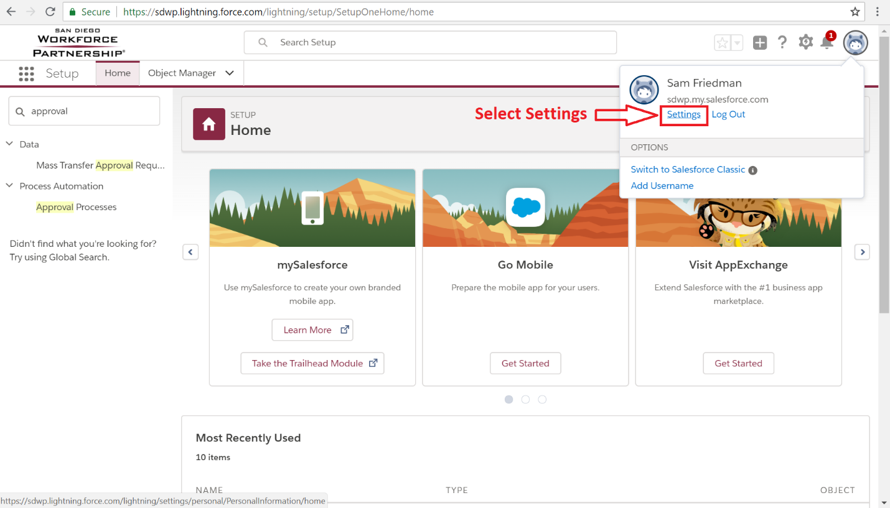
Figure 2. Select “Settings” from your Profile Menu in order to access and configure your personal settings in Salesforce.
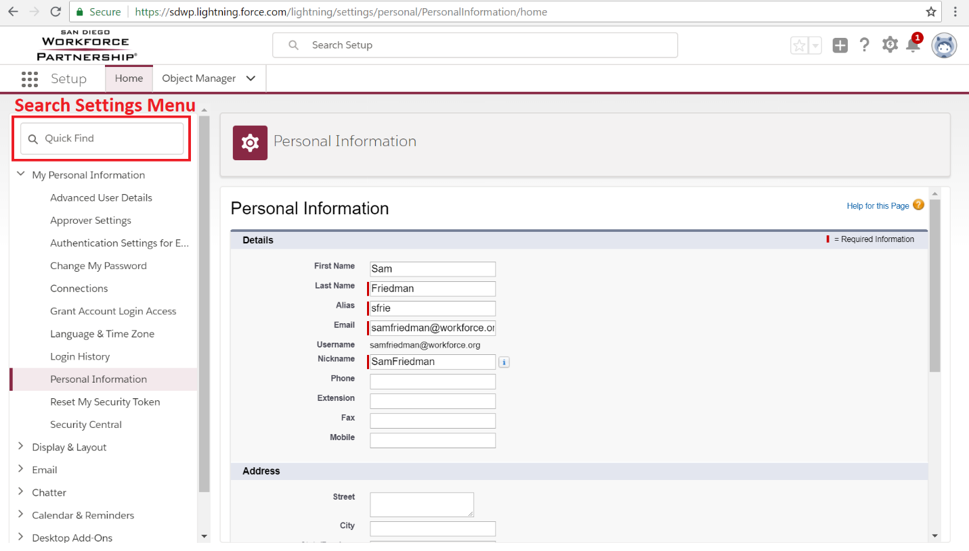
Figure 3. The Personal Settings Menu can be searched using the search field to access settings quickly.
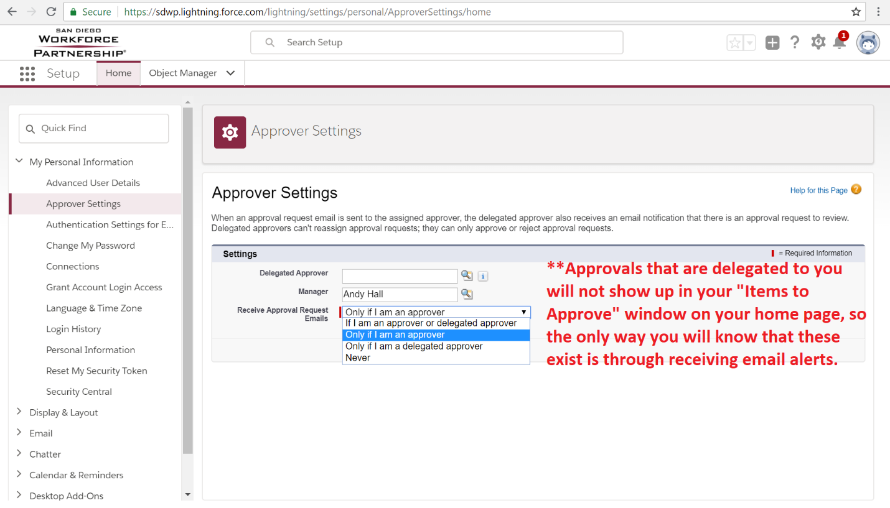
Figure 4. The Approver Settings menu is where you can set whether you want to receive emails as a delegated approver or just when you are the approver of an Agreement or other object that uses an approval process. You can also change who your delegated approver is in this menu.
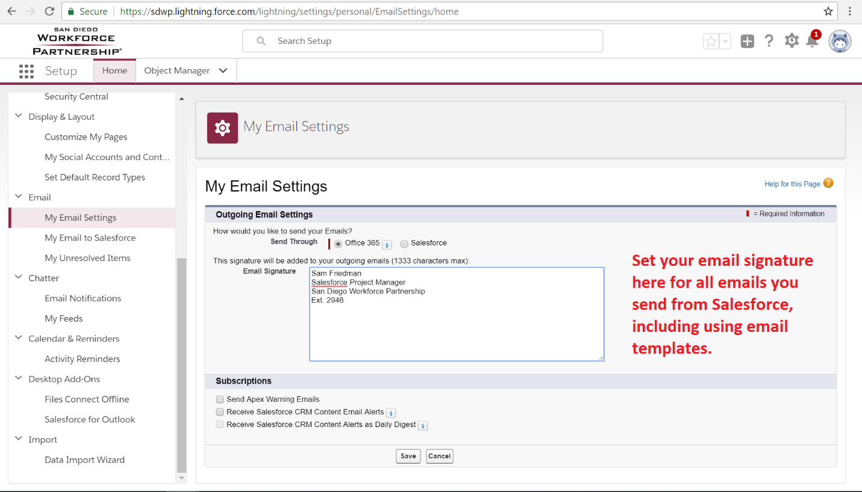
Figure 5. You can change your email signature here in “My Email Settings.”

Email Signatures
The following format should be used for all personal email signatures:
Sam Friedman
Salesforce Project Manager
San Diego Workforce Partnership
Office: (619) 228-2964
workforce.org

Facebook | Twitter | LinkedIn
Opportunity through work

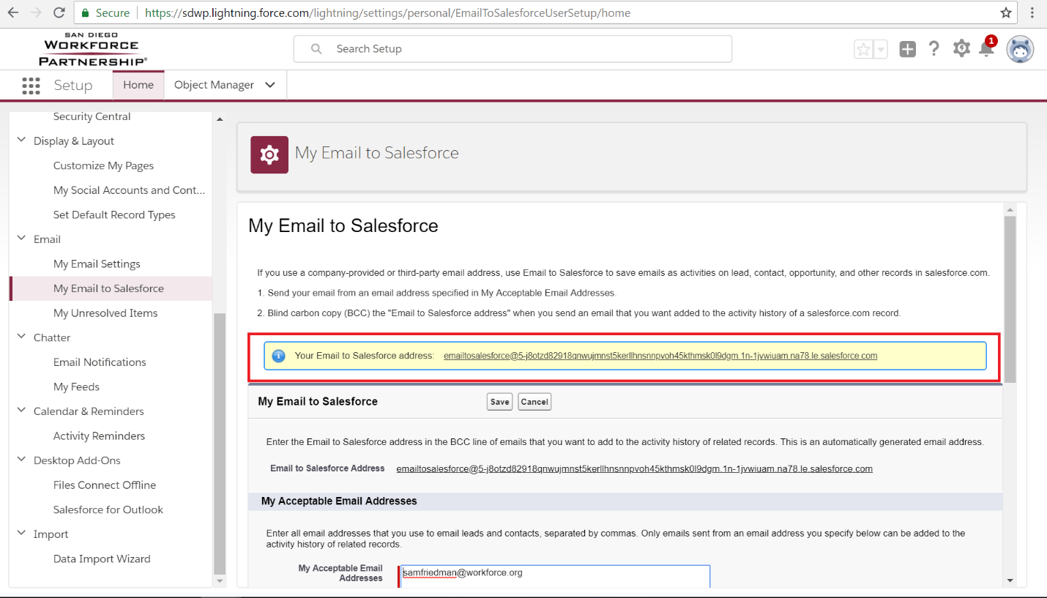
Figure 6. Use your personalized “Email to Salesforce” address in the BCC line of emails you send to automatically attach the email as an activity on the Salesforce record of the Contacts that correspond with the email address(es) you are sending the email to. For example, if you send an email to JohnSmith@gmail.com and bcc the Email to Salesforce address, then the email will be automatically attached to the Contact record for John Smith if he is an existing contact in Salesforce with that email.
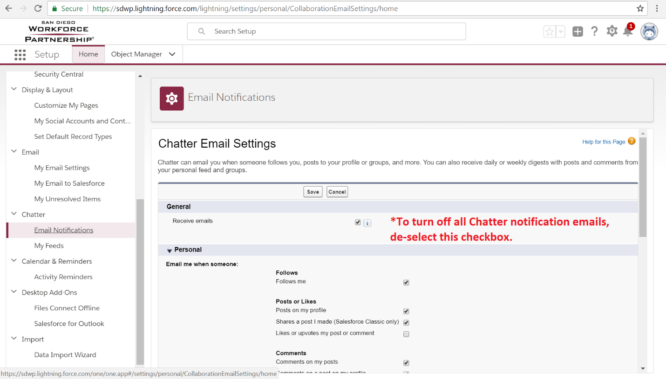
Figure 7. You can customize or turn off Chatter notifications that are sent to your email from this settings menu.
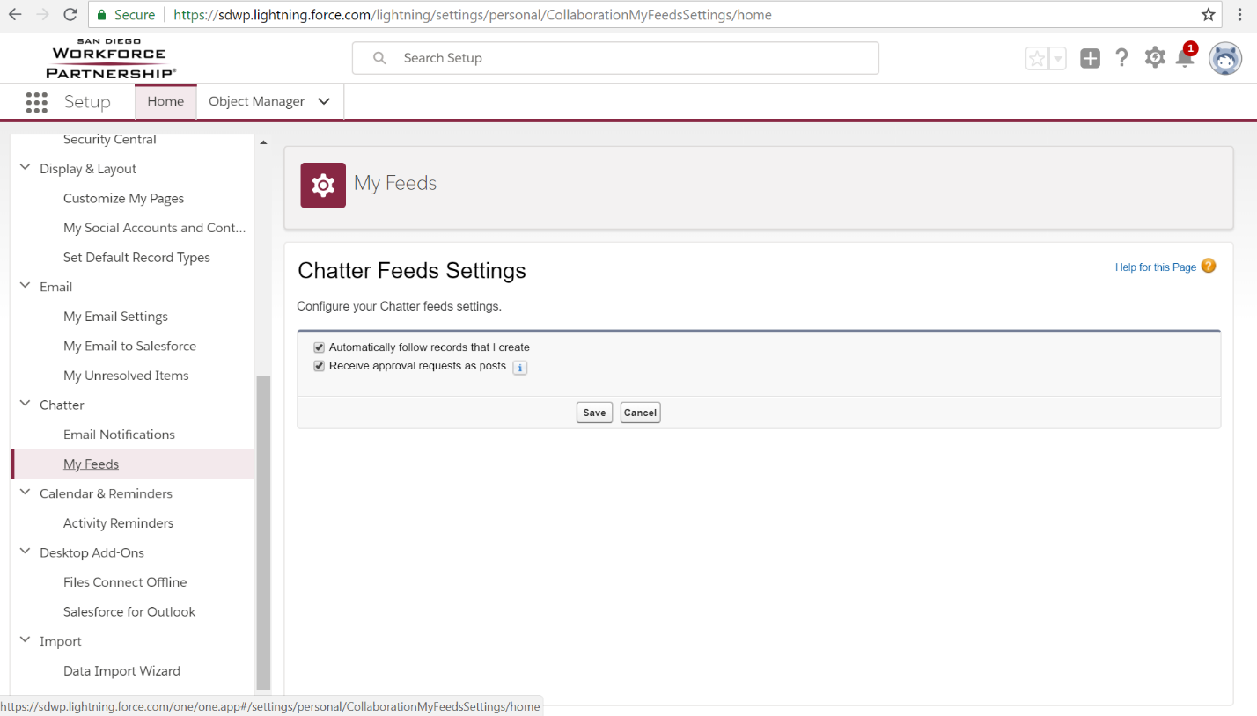
Figure 8. Here you can choose whether you want to follow all records that you create in Chatter. When you follow records in Chatter, you will receive updates about that record as changes are made directly in your Chatter feed.
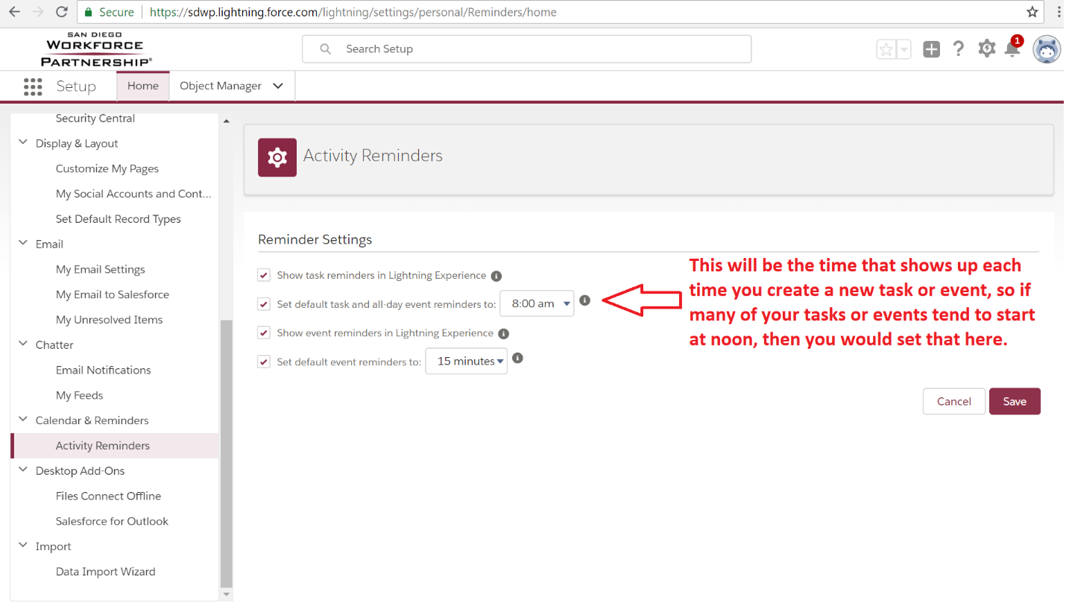
Figure 9. You can adjust your task and event settings and reminders in this menu, including the default time that is used when you create new events.
Configure Salesforce Profile
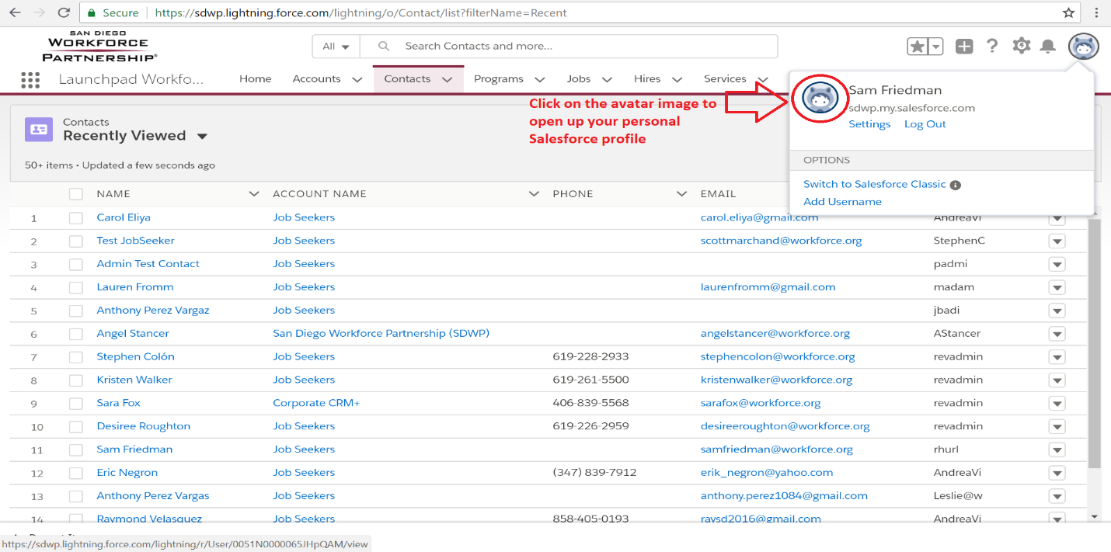
Figure 11. Click on the avatar icon in your Profile Menu to access your profile.
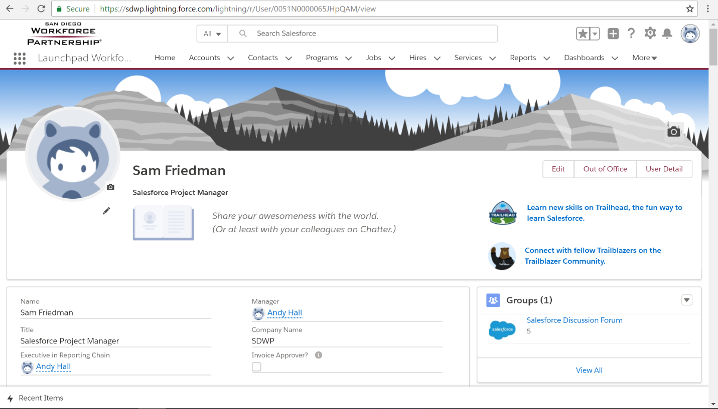
Figure 12. Your profile is where you get to upload an image, share a little about yourself in a bio, and adjust some basic user settings and contact details. You can also see your Chatter feed, groups you are a part of, followers, others you are following, and all the files you have uploaded to Salesforce on this profile page.

