Common Salesforce Terms

App
An app, or application, in Salesforce is a set of objects, fields and other functionality that supports a business process. You can see which app you’re using and switch between apps using the App Launcher (). We currently use the Launchpad app, and this will be the only app that most users will need to access.

Objects
Objects are like excel spreadsheets; they store a particular kind of information. You can find objects in either the navigation bar near the top of the page or in the App Launcher () menu located at the top left of the screen.
Standard objects are objects that are included with Salesforce. Among others, Accounts, Contacts, Groups, Tasks, Meetings, Chatter, Reports, and Dashboards are all standard objects.
Custom objects are objects that you create to store information that’s specific to your company or industry. For example, the Agreements object is a custom object.

Records
Records are like the rows in an excel spreadsheet; they are the actual data associated with an object. For example, if you create a new Contact named Joe Smith, then you are creating Joe Smith’s Contact record.
When you view the details of a record by clicking on it, this is called the Record Detail Page.

Fields
Fields are like columns in an excel spreadsheet. Both standard and custom objects have fields. For example, the Account object has many fields including Account Name, Description, Location and Phone, and you will see these fields when you view the Record Detail Page.
Fields may be edited either during record creation or while editing a record.

Permissions
Record Level Security
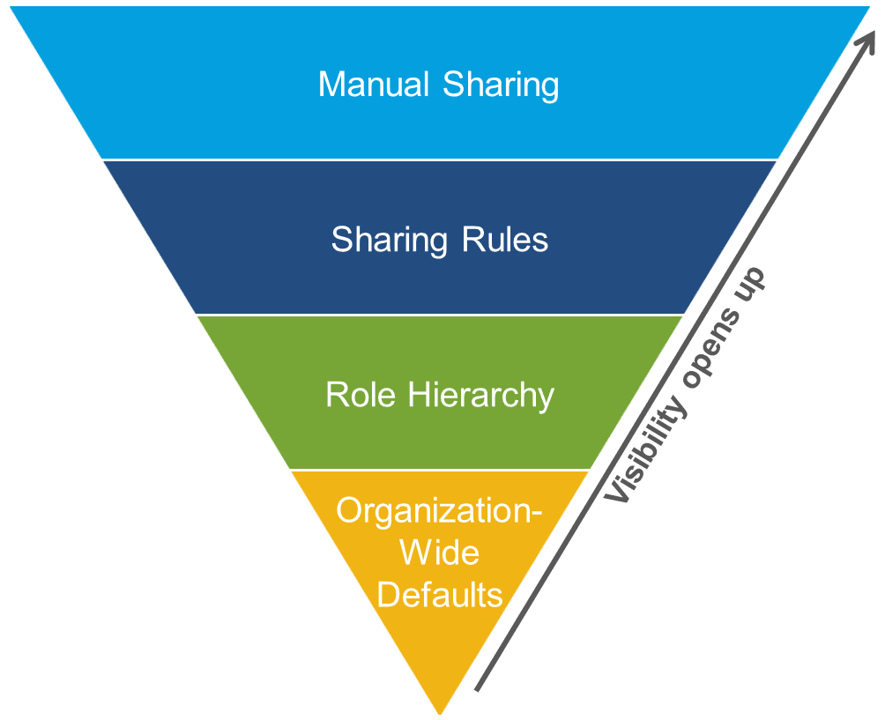
Organization-Wide Defaults specify whether you can view and/or edit records that you do not own. Settings include private, public read only or public read/write. To illustrate through an example, agreements are private, so only record owners (those who create the agreements) can see their own agreements. An additional option in this case is that role hierarchy is enabled for this object, which means that supervisors may also see the agreements of their teams. As another example, Contacts are public read/write, so all users may freely view and edit all contacts, even if they are not the record owners.
Role Hierarchy places users within the organizational hierarchy, and users can access the data of all other users directly below them in the hierarchy. Therefore, when the Org-Wide Default is set to private for an object, then the CEO can view records of all users on this object, while directors can only view the records of their departments, and managers can only view their specific teams.
Please keep in mind that if an object is public read or public read/write in the Org-Wide Defaults, then all users will be able to view those records, regardless of the role hierarchy.
The role hierarchy may be disabled for specific objects if more privacy is required.
Sharing Rules are automatic exceptions to org-wide defaults for particular groups of users, to give them access to records they don’t own or can’t normally see. These can open up permission to records for particular users, but cannot be more restrictive than the Org-Wide Defaults.
Manual Sharing lets record owners give read and edit permissions to users who might not have access to the record any other way.
Object Level Security
Profiles consist of a collection of settings and permissions. Profile settings determine which objects the user can see as well as system permissions, such as whether or not the user can edit dashboards or transfer ownership of records. Each user has one profile.
Permission Sets is a collection of settings and permissions that give users access to various tools and functions. The settings and permissions in permission sets are also found in profiles, but permission sets extend users’ functional access without changing their profiles.
Permission sets make it easy to grant access to the various apps and custom objects in your org and to take away access when it’s no longer needed.
Users can have only one profile, but they can have multiple permission sets.

Field Level Security
Field Permissions control whether a user has access to view a specific field as well as whether they are able to edit that field. This permission can be set either through profiles or permission sets. These may also be adjusted by accessing the object in the Object Manager located in the setup menu.
Please note that this permission is not the same as setting whether a field is visible, required or read-only on a page layout.

More Resources:
https://trailhead.salesforce.com/modules/data_security/units/data_security_records

Page Layouts
Page Layouts refer to the specific way fields appear when you first create a record as well as when you view the record detail page. Page layouts can be edited to show or not show particular fields, related lists, and custom buttons, links and actions.

Record Types
Record Types are used to create different page layouts for the same object based on either the choice of the user or certain criteria. For example, in the agreements object, there are several different record types, including Purchase Requests, Travel Requests, Service Agreements & Contracts, etc., and each of these has a different layout.

List Views
List Views are the list of records within a certain object. When you first click on an object tab, you will see the “Recently Viewed” list view, which will show you records that you recently accessed. Users will only be able to see records that they have access to.
These list views can be customized to sort and filter data based on criteria, and you can also create charts based on the results in some cases.
The List View may also be alternately viewed as a Kanban view rather than as a table, which is available in the list view next to the settings button (gear icon).

Personal Settings
Personal Settings can be adjusted to access and change preferences for email settings, chatter feeds and notifications, related list layouts, contact and user information, task and event settings, Salesforce for Outlook desktop application setup, and Data Import (disabled for most users). For more information, please refer to the Salesforce Personal Settings Guide.

Chatter
Chatter is a communication tool in Salesforce that allows you to post comments, polls, and questions that can be related to specific users, records and groups.
Your Chatter feed is a stream of everything in Chatter that’s relevant to you, including what you follow, posts where you are mentioned and records that are related to you that have had certain changes made to them (based on feed tracking settings). For example, if you wanted to see every public post that your manager shares on Chatter, then you would follow your manager and their posts would then populate your feed.
In order to include a user in a chatter post, use the @ symbol and begin typing their name, at which point a dropdown menu will populate where you are typing and you may select the user you wish to include in your comment. When you tag a user in this way, your post will show on their feed and they will be emailed and receive a notification that they were included in a comment. These posts will also show in their Chatter object page under the “To Me” tab.
Similarly, using the / character and searching for and selecting a specific record from the resulting dropdown will allow you to relate your post to that record, and your post will then automatically show on that record detail page’s chatter feed.
You can create more specific feeds, called streams, which allow you to only show specific records, groups and people that you choose. This can be accessed in the Chatter object, which can be found in the App Launcher Menu ().
Chatter posts will automatically be shared with the people related to the post or record. Therefore, if you create a chatter post in a group, then members of the group will see the post, and if you post on a record, those who are following that record will be notified about the post. You will not receive notifications for your own posts.
In order to interact with a Chatter post, you can like it or comment on it. You can also bookmark a post, which saves it to your “Bookmarked” feed, which can be accessed in the Chatter object.
You can also attach files to a Chatter post, and these will be saved in Salesforce as your files.
Note: If you would like to adjust your preferences for if or when Chatter sends you email notifications, you may do so by accessing your personal settings and selecting the Chatter à Email Notifications options in the left sidebar menu.

Salesforce to Outlook Integration
Lightning for Outlook is the cloud-based application that will run both within the Outlook client (desktop application) and on the web (i.e. using Outlook in your internet browser). This Outlook add-in can be used to access Salesforce records inside of Outlook by selecting an email and then clicking on the “View” icon with a blue Salesforce cloud image in the tool bar menu under the “Home” tab (see figure 1). This will launch a Salesforce sidebar menu (see figure 2) that will allow you to log emails inside of Salesforce. For example, if you log an email into Salesforce related to the contact that you received the email from, then this email would appear inside of Salesforce under that contact’s record detail page in the Activity tab under “Past Activities” (see figure 3).
The contacts and accounts that populate this menu are taken directly from the email addresses in the To/From/CC email fields for that specific email, and these email addresses are then compared with all of the contacts and accounts in Salesforce to find records that match these emails.
Figure 1. Select the Lightning for Outlook add-in under the Home tab and Log Emails to contacts or accounts and add tasks and events.
Figure 2. When you select “Log Email” the next screen will allow you to select which contacts and/or accounts you would like to log this email to inside of Salesforce.
Figure 3. When you log emails to Salesforce, they will populate in the corresponding contact or account record under the Activity tab under “Past Activities.”
Lightning for Outlook is the successor to Salesforce for Outlook, which is a desktop application that can be manually downloaded and installed, and this application only supports Windows/PC users. All users are currently using Lightning for Outlook, so installation of Salesforce for Outlook is unnecessary and therefore discouraged to avoid potential errors.

Email to Salesforce is an alternate method to logging outgoing emails to Salesforce without having to manually do so via the Lightning for Outlook menu in Outlook. In order to utilize this feature, you must first locate your personal Email to Salesforce email address, which can be found in your personal settings menu under Email à My Email to Salesforce. You will then copy the email address located in this window and BCC this address when you send an email that you want added to the activity history of a Salesforce record related to whom you are sending the email to. In order to ensure this is working properly, please verify that the email address listed in “My Acceptable Email Addresses” is your current email address. If it is not, you may add your current valid email address after the one listed, separated by a comma, and please also contact your Salesforce administrator to verify that your email address is valid in your Salesforce user record.

Learning Resources
Salesforce Standard Term Glossary:
https://help.salesforce.com/articleView?id=glossary.htm&type=0

Helpful Trailhead Learning Resources:
Get Started with the Salesforce Platform (10 mins): https://trailhead.salesforce.com/trails/force_com_admin_beginner/modules/starting_force_com/units/starting_intro

Get Started with Lightning Experience (15 mins):
https://trailhead.salesforce.com/modules/lex_migration_introduction/units/lex_migration_introduction_whatis

Reports & Dashboards for Lightning Experience Module:
https://trailhead.salesforce.com/en/modules/lex_implementation_reports_dashboards

